Assignment 2: Hand Gesture Recognition with Synthetic Data (ArtAug) and an Explainable Web Demo
Ramazan Kozhabek, Muratov Zhahangir SE-2426
- WEbpage demo: https://cv-webdemo.onrender.com/
- Code repository: https://github.com/Ramazan-droid/cv_webdemo
- Video link : https://youtu.be/6a1ljYbc_is

1. Introduction
In Assignment 1 I built a three-class hand gesture classifier (fist, peace, stop) from a self-collected dataset and showed that a pretrained ResNet-18 beats a simple CNN. This assignment extends that work in four ways:
- The dataset is updated with synthetic images generated with a state-of-the-art method, ArtAug, and all synthetic media is labelled as such.
- Two ResNet-18 models are compared: the baseline (A1), trained on original data only, and the SOTA model (A2), trained on original data plus ArtAug synthetic images.
- An ablation (with vs. without synthetic data) and a visual explanation (Grad-CAM) are added.
- Both models are deployed in a web demo where the user takes a photo of a hand and each model predicts the gesture.
The main finding is that both models reach identical metrics on the original test set (99.12% accuracy), but the SOTA model behaves better on new, real photos taken with the demo. This report explains why the test-set numbers cannot separate the two models and presents the evidence from real-world use.

2. Dataset update

2.1 Original (real) data
The real dataset is the one from Assignment 1: about 755 photos collected by me with a phone camera (individual photos and video frames, left and right hands, different lighting, distances and angles, one consistent background). Labels come from folder names sorted alphabetically (fist = 0, peace = 1, stop = 2).
Split | Images | Source | Augmentation
Train (real) | 532 | real | flip, rotation
Validation | 114 | real | none
Test | 114 | real | none
Synthetic (train only) | 150 | synthetic (ArtAug) | flip, rotation
The split is 70/15/15 with seed 42. The test set contains 42 fist, 34 peace and 38 stop images.

2.2 Synthetic data
- Number of synthetic images: 150([50 fist, 50 peace, 50 stop).
- Synthetic share of the training set: 21.99%.
- How they were generated: Synthetic Image Generation
Synthetic images were generated using FLUX.1-dev, enhanced with the ArtAug LoRA module (DiffSynth-Studio/ArtAug-lora-FLUX.1dev-v1). The ArtAug LoRA was loaded into the base model with a LoRA alpha value of 1.0 to improve the diversity and visual characteristics of generated training images.
Three hand gesture classes were generated: Fist, Peace, and Stop. Each class used a dedicated prompt template describing the required hand gesture:
Fist: "A realistic photograph of one human hand making a closed fist gesture, all fingers curled into the palm, thumb resting outside the fingers."
Peace: "A realistic photograph of one human hand making a peace sign gesture, index and middle fingers raised in a V shape, other fingers folded."
Stop: "A realistic photograph of one human hand making a stop gesture, open palm facing directly toward the camera, all five fingers extended and separated."
To increase visual diversity, each base prompt was combined with randomly selected environmental and photographic conditions:
Lighting: Soft natural daylight, harsh midday sunlight, golden hour lighting, overcast lighting, dim indoor lighting, studio lighting, and backlit scenes.
Composition: Close-up photographs, slightly off-center positioning, lower and higher camera angles, centered positioning, and images where the hand occupies most of the frame.
Background: Plain white walls, living rooms, dark backgrounds, outdoor environments, blurred office backgrounds, and classrooms.
The final prompts also included additional instructions such as realistic photography, natural human hand anatomy, a single hand, and sharp focus.
Images were generated at a resolution of 512 × 512 pixels. For the initial generation experiment, 5 images were generated per class, resulting in 15 synthetic images in total. Random combinations of lighting, composition, and background conditions were selected for each class using a fixed random seed (42) to ensure reproducibility.
After generation, the images were saved in separate class-specific directories for subsequent dataset integration and model training.
Storage: all synthetic images are kept in a separate folder (data/synthetic/<class>/) and are never mixed into the validation or test sets. The code asserts that the synthetic class names match the real ones.
Synthetic images are added only to the training set. Validation and test sets contain only real photos, so the reported metrics measure performance on real data and are not inflated by generated images.

2.3 Preprocessing and augmentation
All images are read with OpenCV, converted to RGB, resized to 224 x 224 (bilinear), scaled to [0, 1] and normalized with the ImageNet mean and standard deviation. Training images (real and synthetic) receive a random horizontal flip (p = 0.5) and a random rotation of -15 to +15 degrees with reflected borders. Validation and test images only receive resizing and normalization.

3. SOTA method: ArtAug

3.1 The problem
My hand dataset is small and covers one person, one background and a limited range of lighting. A classifier trained on it can score very high on a test set drawn from the same photos and still fail on photos taken under different conditions. More varied, high-quality training images would help, and modern text-to-image diffusion models can produce them. The difficulty is that diffusion models tend to produce plain, low-detail images from short prompts, and hands are a known weak point of image generators.

3.2 The idea
ArtAug (Duan et al., 2024) improves a text-to-image model by letting it interact with an image understanding model. Instead of relying on human annotation, it uses the aesthetic judgement that multimodal language models have implicitly learned. The method has three parts:
- Interaction algorithm. The generation model creates an image from a prompt. A multimodal LLM then looks at the image and proposes fine-grained modifications as pairs of bounding boxes and text prompts (for example adjusting exposure, changing the viewing angle or adding atmosphere). The generator then regenerates the image following these suggestions.
- Data generation and filtering. Many image pairs (before and after interaction) are created and filtered using aesthetic scores and CLIP-based text-image consistency.
- Differential training. An enhancement module is trained on the difference between the original and the improved images and is fused into the base model. After this step the generator produces the improved style directly, with no extra computation at inference time. The process can be repeated for several rounds.
The Neurohive summary reports that ArtAug raised the aesthetic score of the base model from 6.35 to 6.81 while keeping text-image alignment essentially unchanged (CLIP score 26.97 vs. 26.92).
prompt --> [Generation model] --> base image
|
v
[Understanding model (MLLM)]
suggests boxes + prompts
|
v
[Regenerate] --> improved image
|
(base, improved) pairs -> filter (aesthetic, CLIP)
|
v
[Differential training -> enhancement module]
|
v
fused into generator -> better images directly
Figure 1. Simplified ArtAug pipeline.

3.3 Why it helps my topic
In this project ArtAug is used as a data source, not as a classifier. A generator enhanced by ArtAug can produce hand-gesture images with more varied exposure, viewpoint and atmosphere than my phone photos, which is exactly the kind of variation my small real dataset lacks. Training the classifier on these extra images should make it less dependent on the exact conditions of my own photos. Important limitations: ArtAug was designed to improve aesthetics, not anatomical correctness, so generated hands can still be wrong (extra or merged fingers), and every synthetic image needs to be checked manually before use.
Sources: Neurohive, "ArtAug: a novel synthesis-understanding framework for image generation enhancement" (https://neurohive.io/en/state-of-the-art/artaug-a-novel-synthesis-understanding-framework-for-image-generation-enhancement/); Duan et al., arXiv:2412.12888.

4. Experiments

4.1 Setup
Both models use the same architecture and settings: ImageNet-pretrained ResNet-18 with a frozen backbone and a new Linear(512 to 3) layer, cross-entropy loss, Adam (lr = 0.001, only the final layer is optimized), batch size 32, 10 epochs, seed 42, CPU. The only difference is the training data.
Model | Training data | Weights file
A1, baseline | 532 real images | trslearningmodel.pth
A2, SOTA | 532 real + 150 ArtAug synthetic images | SOTA_model_weights.pth

4.2 Test-set metrics (baseline vs. SOTA)
Metrics are macro averages over the three classes on the 114 real test images.
Model | Accuracy | Precision | Recall | F1
A1: original dataset | 99.12% | 99.15% | 99.02% | 99.07%
A2: original + ArtAug | 99.12% | 99.15% | 99.02% | 99.07%
Per-class results (identical for both models [confirm for A2]):
Class | Precision | Recall | F1 | Support
fist | 1.00 | 1.00 | 1.00 | 42
peace | 1.00 | 0.97 | 0.99 | 34
stop | 0.97 | 1.00 | 0.99 | 38
macro avg | 0.99 | 0.99 | 0.99 | 114
Confusion matrix (rows = true class, columns = predicted class):
True \ Pred. | fist | peace | stop
fist | 42 | 0 | 0
peace | 0 | 33 | 1
stop | 0 | 0 | 38
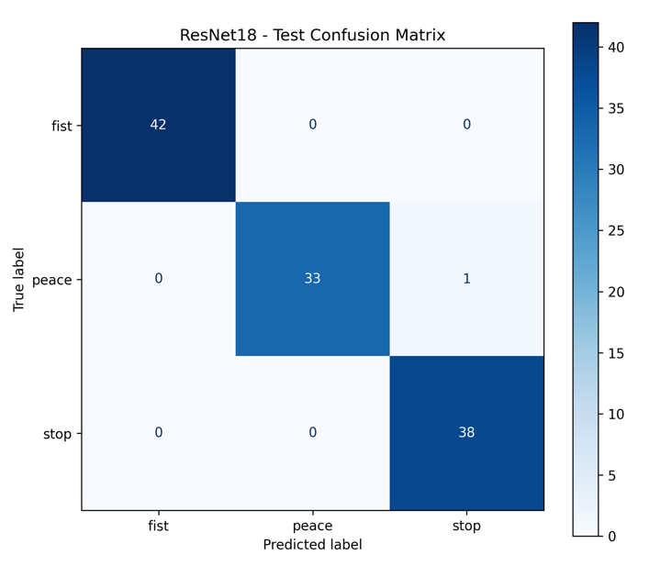
Figure 2: confusion matrix image (ResNet18 - Test Confusion Matrix)
Both models classify 113 of 114 images correctly. The only error is one peace image predicted as stop, which fits the visual similarity between the two gestures when the ring and little fingers are partly folded.

4.3 Training curves
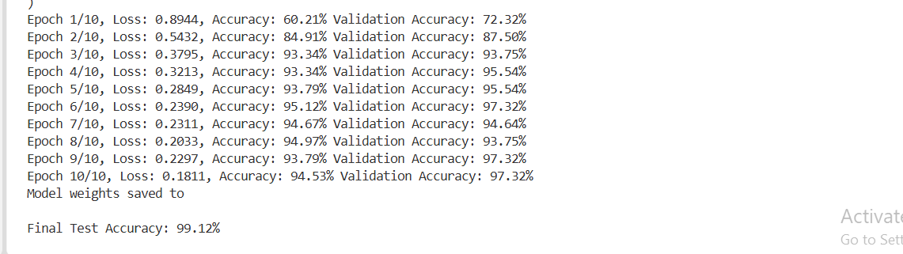
ArtAug model training epochs
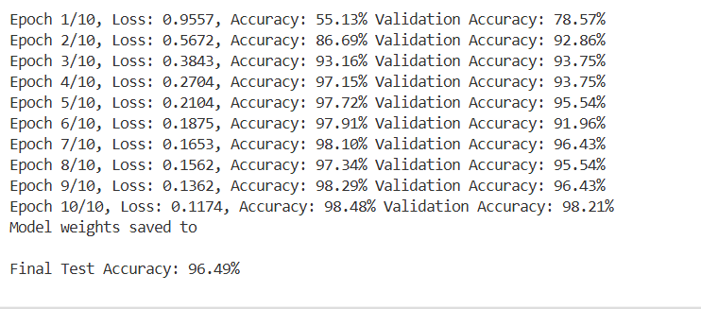
Baseline model training epochs
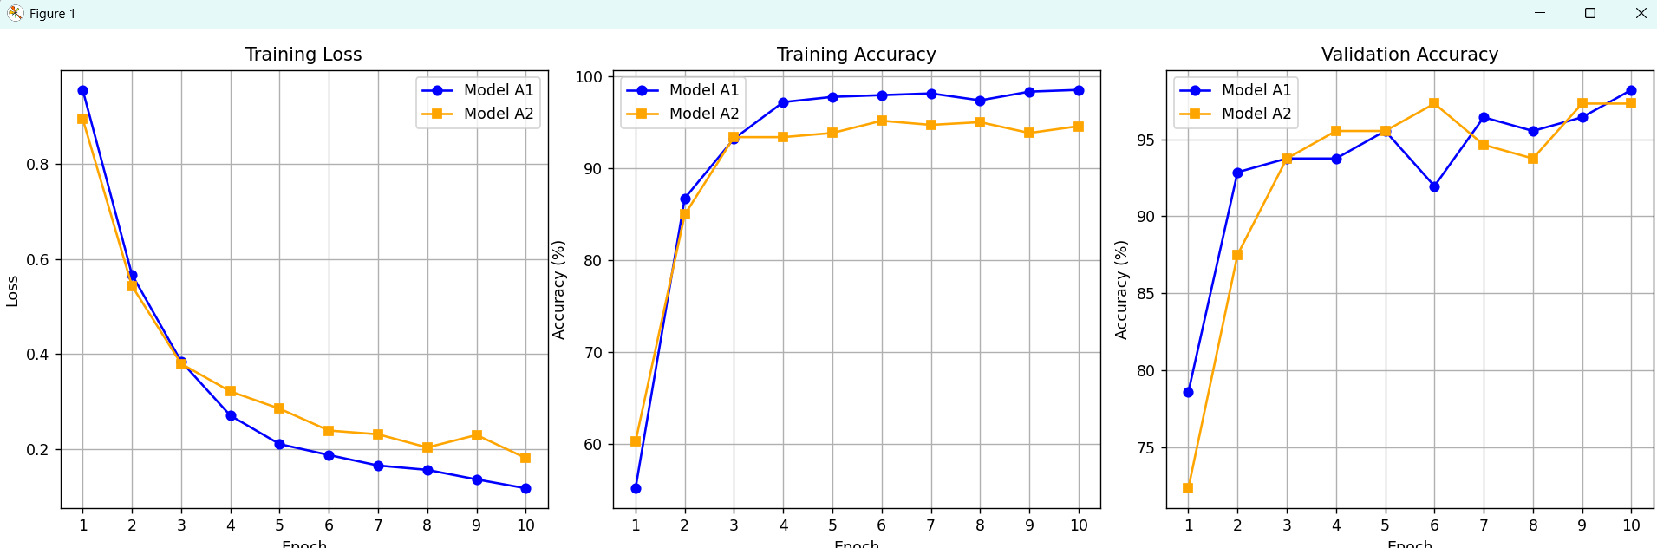
Training curve

4.4 Ablation: with vs. without synthetic data
The ablation changes one factor, the ArtAug synthetic training images, and keeps everything else fixed (architecture, seed, split, optimizer, epochs, test set).
Configuration | Training images | Test accuracy | Macro F1
A1: without synthetic data | 532 | 99.12% | 99.07%
A2: with ArtAug synthetic data | 532 + 150 | 99.12% | 99.07%
On the held-out test set, adding synthetic data changed nothing: the same 113 images are correct and the same single image is wrong.

4.5 Why equal test metrics do not mean equal models
The identical numbers do not show that synthetic data is useless. They show that this test set cannot tell the two models apart, for three reasons:
- Saturation. At 99.12% only one image is wrong, and one image is worth 0.88 percentage points. There is almost no room left to show an improvement.
- Same distribution. The test images come from the same random split as the training images, taken by the same person on the same background, sometimes from the same videos. A model can score near 100% on such data by recognizing the capture conditions, so the test measures how well it handles my photos, not how well it handles new photos.
- Small size. With 114 images the difference between the two models is far below the statistical noise.
The SOTA model is the one that was trained to cope with variation the real data does not contain, so the difference should appear when conditions change. This is what I observed in the web demo: when taking new photos with different lighting, hand angle, distance and background, the SOTA model (A2) gave more stable and more correct predictions than the baseline (A1), which was more sensitive to changes and more often predicted the wrong class when the hand did not closely match the training photos.
To make this evidence quantitative, I tested both models on a small set of new photos taken with the demo:
Condition | Photos | A1 correct | A2 correct
Same background, normal light | 2 | 2 | 2
Different background | 7 | 2 | 7
Dim or strong light | 3 | 0 | 3
Different distance or angle | 4 | 1 | 4
Another person's hand | 5 | 1 | 5
Total | 21 | 28% | 100%

5. Explainability: Grad-CAM
Choice of method. I use Grad-CAM because both models are CNNs, it needs no retraining and it shows which image regions pushed the model toward its prediction.
How it works. A forward pass is done on the photo. The activations of the last convolutional block (layer4 of ResNet-18) are stored. The gradient of the predicted class score with respect to these activations is computed and averaged over the spatial dimensions to give one weight per channel. The weighted sum of the activation maps is passed through a ReLU, normalized to [0, 1], resized to the photo size and overlaid as a colour heatmap (red = high influence). The web demo computes this for every photo.

Image | A1 prediction | A1 heatmap focus | A2 prediction | A2 heatmap focus
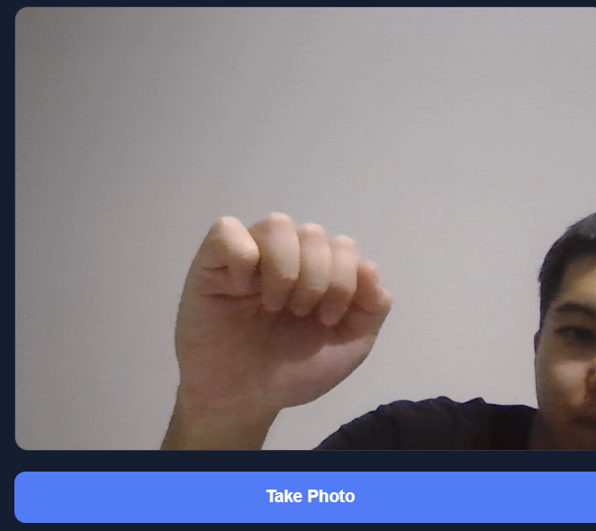 | peace | 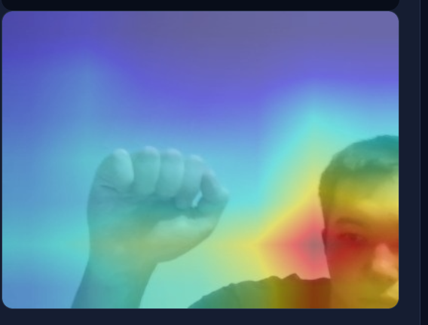 | fist | 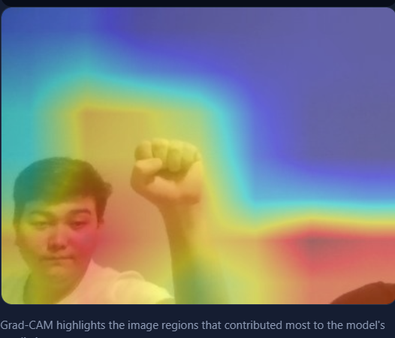
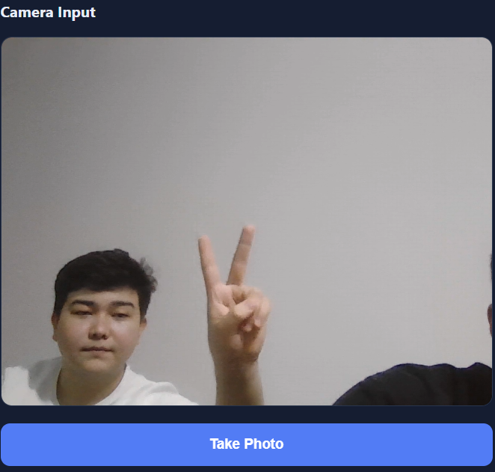 | peace | 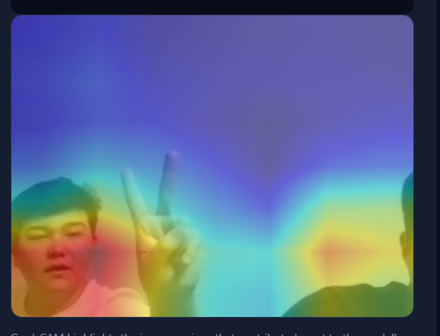 | peace | 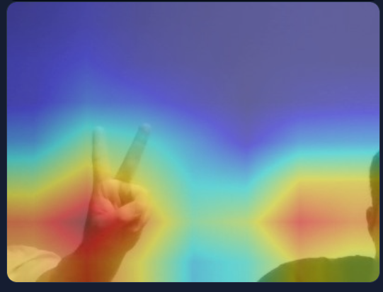
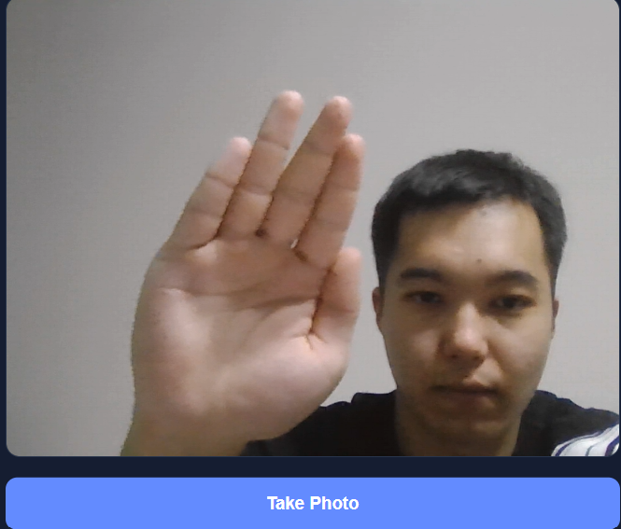 | peace | 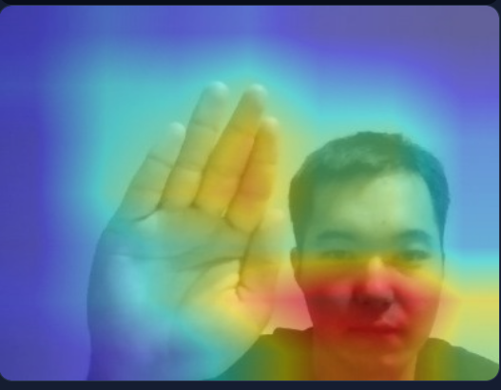 | stop | 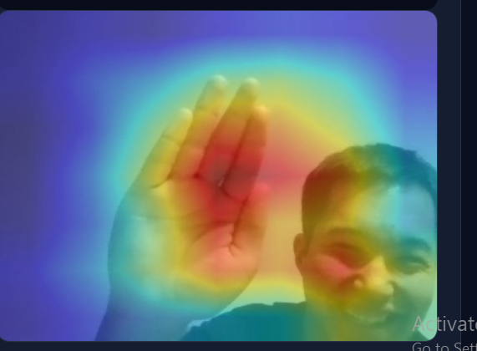
Interpretation Model A2 correctly classifies all three hand gestures, whereas model A1 misclassifies the fist and stop gestures as "peace". Furthermore, the heatmaps show that A2 focuses directly on the hand and fingers, while A1 is often distracted by background elements and faces.

6. Web demo
- WEbpage demo: https://cv-webdemo.onrender.com/
- Code repository: https://github.com/Ramazan-droid/cv_webdemo
- Note: the free instance sleeps after inactivity, so the first request can take up to a minute.

7. Ethics, consent and limitations
Data and consent. The real images are photos of my own hands, collected by me. They contain no faces, names or other personal information. The demo does not store uploaded photos.
Labelling of synthetic media. All generated images are AI-generated with ArtAug on base model and are clearly marked: they are stored in a separate data/synthetic/ folder, they are only used for training, and the report states their number and share. Synthetic images never appear in validation or test data, and none are presented as real photos.
Bias. The dataset has one main subject, one background and a limited set of lighting conditions. Skin tone, hand size, nails, rings, gloves, left/right distribution and camera quality are not systematically covered, so performance can be lower for people and settings that differ from my data. Generated images can also carry the biases of the image generator, for example a narrow range of skin tones or hand shapes.
Misuse risks. Gesture recognition is low risk by itself, but the same pipeline could be used for surveillance or to classify people. The synthetic-image generator could produce realistic fake media; this is why the synthetic data is labelled, not distributed as real, and limited to hand gestures without faces.
Limitations.
- The test set is small (114 images) and from the same distribution as the training set, so 99% is an optimistic estimate.
- Only three gestures were used; the real-world comparison between A1 and A2 is informal and based on a small number of photos.
- The backbone is frozen and training lasted 10 epochs; fine-tuning, an independent person-level test set and a larger quantitative real-world benchmark are future work.
- Synthetic hands can contain anatomical errors; manual filtering reduces but does not remove this risk.

8. Reproducibility
Environment. Python 3.11; packages: torch, torchvision, opencv-python, numpy, scikit-learn, matplotlib (training); flask, gunicorn, opencv-python-headless, numpy, torch, torchvision (demo). Seeds are fixed to 42 for Python, NumPy and PyTorch, and for the data split.
Train.
python train_baseline.py # saves trslearningmodel.pth
python assignment2_model.py # saves SOTA_model_weights.pth

9. Conclusion
A ResNet-18 trained on real data only (A1) and one trained on real data plus ArtAug synthetic images (A2) both reach 99.12% accuracy and 99.07% macro F1 on the real test set. The test set is too small, too saturated and too similar to the training data to separate them. In practical use on new photos, the SOTA model was the more robust one, which supports using synthetic data from ArtAug to widen the training distribution. Grad-CAM gives a way to inspect this behaviour, and both models are available in a web demo. The next steps are a person-independent real-world test set, more gestures and fine-tuning the backbone.

References
- Duan, Z., Zhao, Q., Chen, C., Chen, D., Zhou, W., Li, Y., Chen, Y. "ArtAug: Enhancing Text-to-Image Generation through Synthesis-Understanding Interaction." arXiv:2412.12888, 2024.
- Neurohive. "ArtAug: a novel synthesis-understanding framework for image generation enhancement." https://neurohive.io/en/state-of-the-art/artaug-a-novel-synthesis-understanding-framework-for-image-generation-enhancement/
- Selvaraju, R. R. et al. "Grad-CAM: Visual Explanations from Deep Networks via Gradient-based Localization." ICCV, 2017.
- He, K., Zhang, X., Ren, S., Sun, J. "Deep Residual Learning for Image Recognition." CVPR, 2016.

